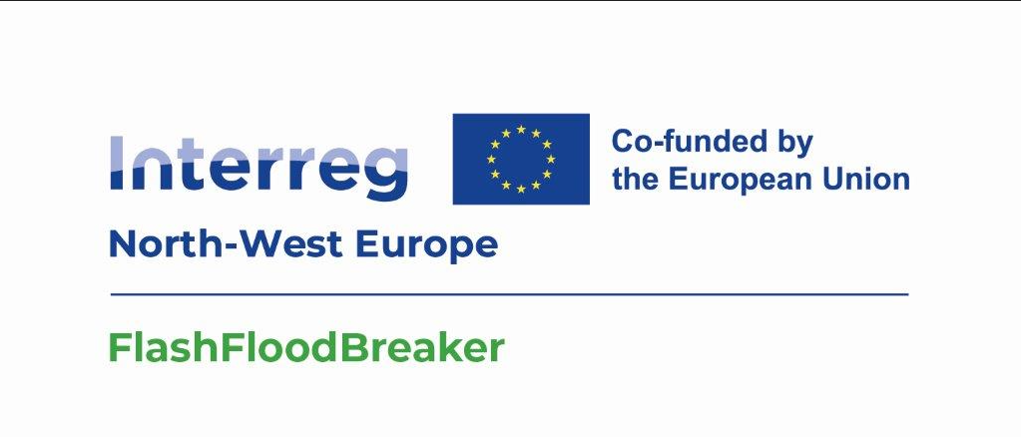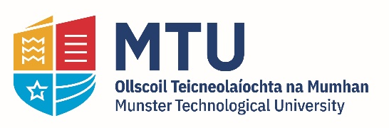
FlashFloodBreaker - PhD Scholarship
Machine Learning

NIMBUS Research Centre and the Sustainable Infrastructure Research & Innovation Group (SIRIG)
MTU Cork Campus
March 2024

PhD Scholarship
The MTU NIMBUS Research Centre and the Sustainable Infrastructure Research & Innovation Group (SIRIG) are pleased to offer a PhD scholarship for research in the area of machine learning and data science. The scholarship is set within the Flash Flood Breaker Project which is a collaborative large-scale project (2024-2027). The project aims to make North-West Europe (NWE) more resilient to increasing extreme flash flood events. The project focuses on assessing flood vulnerability, developing a flood-resilient framework, reducing flood hazards and creating a decision-making platform to tackle extreme flash floods in real-time. To facilitate this research, the PhD candidate will be expected to review and develop machine learning methodologies applicable to time series, geographical and drone image data sets with a view to augmenting system response to flash flood events.

The project is funded through the Interreg NWE Programme with a large multi-partner project team.

Project Background and Detail
The project will test innovative integrated modelling, AI-based forecasting and real-time data collection by drones applicable throughout NWE. Furthermore, it aims to demonstrate responsive flood communities for emergency response at the local and transnational levels and integrate validated solutions into strategy/action plans to manage floods in the future.

NWE has been strongly affected by extreme flash flood events in recent years. July 2021 is one devastating example of the impact an extreme flash flood can have, where over 200 fatalities and widespread damages and infrastructures disruption were recorded in DE, BE, NL, LU, FR, IE and CH. A flash flood is a rapid rise of water in low-lying areas that occurs within only 3-6 hours of a heavy rainfall. Due to climate change (more frequent extreme weather events) and increasing settlement of residential and commercial buildings, the flash flood risk is increasing in NWE.

NWE-territories at a higher risk are urban, polder and steep valley areas. In those areas, flash floods can originate from both fluvial and pluvial sources. In case of fluvial sources, flash floods arise from tributaries. Adapting to extreme flash flood with conventional protection methods is restricted due to land-use constraints. Thus, there is a need to develop new techniques to effectively manage extreme pluvial and fluvial flash flood-related risks in NWE to avoid/minimise human and economic losses and damages. Such approaches are envisaged to incorporate state-of-the-art machine learning and deep learning algorithms for time series forecasting and computer vision classification.

To tackle flash flood disasters, the project will develop and test new holistic approaches by integrating hydrological modelling with AI and machine learning tool, collection of data in real time using drone survey. Pluvial and fluvial models will be combined to carry out stress tests of the current flood protection systems and assess its vulnerability. Further, the impacts of the cascading effects will be integrated to current inundation models to predict material and economic impacts of flash floods in the different risk-affected areas.

To support emergency response, innovative data-driven approaches to real-time forecast inundation extent and impacts or using drones will be piloted for the first time in the distinct areas. On this basis, early warning systems can be upgraded to alert crisis management units and citizens of upcoming flash floods and help them make collective or individual decisions.

PhD Scholarship Details

The successful candidate will receive a stipend of €21,000 per annum for the duration of the PhD (up to December 2027) and an annual contribution of €6,000 towards tuition fees. Attendance at project meetings and conferences will be facilitated.

An outline of the work which the successful candidate will undertake as part of his/her/their research PhD thesis as part of the Flash Flood Breaker Project includes:
- State-of-the-art literature review – Key words: Machine Learning, including deep learning for time series and image datasets. Data retrieval and data pre/post processing for data science.
- Wide ranging interaction with industry stakeholders (e.g., County and City Councils, Contractors, Government Agencies, Digital Providers etc.) nationally and internationally to inform the development of data driven flash flooding model algorithms.
- Production of project reports, and dissemination publications as required.

This research position, which is currently available, offers candidates an opportunity to work within a large EU research consortium and as part of a multidisciplinary research environment within MTU. The PhD candidate will have opportunity for national and international travel to conferences and for project collaboration. The PhD candidate will also work closely with colleagues in MTU in the NIMBUS Centre and Sustainable Infrastructure Research & Innovation Group.

Applicants should hold a Bachelor degree (minimum final grade 2.1 or equivalent) or a Master Degree in Computer Science, Computer Engineering, Data Science and Analytics, or related disciplines. A Masters Degree in Artificial Intelligence or Machine Learning would be desirable with strong programming skills.

The following are desirable:
Have a knowledge and experience of working with the following machine learning methodologies and tools: Tensorflow, PyTorch, Keras, Scikit-Learn, Pandas and NumPy.
Fluency in English and excellent written and oral presentation skills are required.

The following are also desirable:
State of the art software development methods and techniques - for e.g., SOA or micro-services; agile; UML; test driven development and design patterns.
Demonstrable skills across a number of the following: Python 3, C++, Java/JEE, MySQL/NoSQL, HTML5, AngularJS/JQuery, MEAN Stack and Open Cloud.
Extensive scientific and/or technical knowledge of software development, i.e., Distributed data management, data structures, algorithms and complexity analysis.
Demonstrable experience in the design, modelling analysis of distributed software systems.

Written applications, in English, should include a concise C.V., a one-page letter of motivation describing why you are interested in this position, an English language test certificate, if applicable and contact details for three references. Along with the application, please include a copy of relevant qualifications such as official university transcripts. Please email applications to Dr. Conor Lynch (conor.lynch@mtu.ie) by 16.00CET /17.00GMT on 27th March. Shortlisted candidates will be called for an interview in April, 2024.

